**TEAM ID -LTVIP2025TMID49836**

**INTRODUCTION**

Introducing SB Foods, the cutting-edge digital platform poised to revolutionize the way you order food online. With SB Foods, your food ordering experience will reach unparalleled levels of convenience and efficiency.

Our user-friendly web app empowers foodies to effortlessly explore, discover, and order dishes tailored to their unique tastes. Whether you're a seasoned food enthusiast or an occasional diner, finding the perfect meals has never been more straightforward.

Imagine having comprehensive details about each dish at your fingertips. From dish descriptions and customer reviews to pricing and available promotions, you'll have all the information you need to make well-informed choices. No more second-guessing or uncertainty – SB Foods ensures that every aspect of your online food ordering journey is crystal clear.

The ordering process is a breeze. Just provide your name, delivery address, and preferred payment method, along with your desired dishes. Once you place your order, you'll receive an instant confirmation. No more waiting in long queues or dealing with complicated ordering processes – SB Foods streamlines it, making it quick and hassle-free.

**SCENARIO:**

**Late-Night Craving Resolution**

Meet Lisa, a college student burning the midnight oil to finish her assignment. As the clock strikes midnight, her stomach grumbles, reminding her that she skipped dinner. Lisa doesn't want to interrupt her workflow by cooking, nor does she have the energy to venture outside in search of food.

Solution with Food Ordering App:

1. Lisa opens the Food Ordering App on her smartphone and navigates to the late-night delivery section, where she finds a variety of eateries still open for orders.

2. She scrolls through the options, browsing menus and checking reviews until she spots her favorite local diner offering comfort food classics.

3. Lisa selects a hearty bowl of chicken noodle soup and a side of garlic bread, craving warmth and satisfaction in each bite.

4. With a few taps, she adds the items to her cart, specifies her delivery address, and chooses her preferred payment method.

5. Lisa double-checks her order details on the confirmation page, ensuring everything looks correct, before tapping the "Place Order" button.

6. Within minutes, she receives a notification confirming her order and estimated delivery time, allowing her to continue working with peace of mind.

7. As promised, the delivery arrives promptly at her doorstep, and Lisa eagerly digs into her piping hot meal, grateful for the convenience and comfort provided by the Food Ordering App during her late-night study session.

This scenario illustrates how a Food Ordering App caters to users' needs, even during unconventional hours, by offering a seamless and convenient solution for satisfying late-night cravings without compromising on quality or convenience.

**TECHNICAL ARCHITECTURE:**

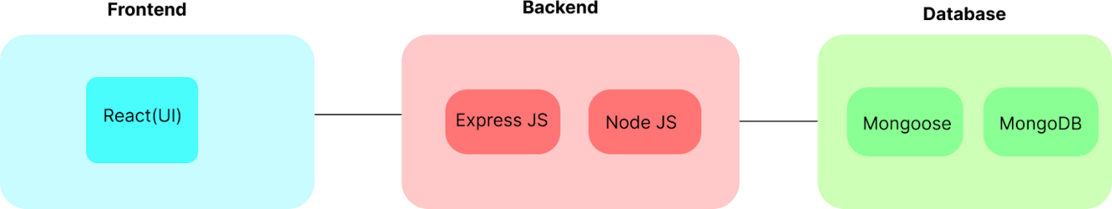

In this architecture diagram:

•        The frontend is represented by the "Frontend" section, including user interface components such as User Authentication, Cart, Products, Profile, Admin dashboard, etc.,

•        The backend is represented by the "Backend" section, consisting of API endpoints for Users, Orders, Products, etc., It also includes Admin Authentication and an Admin Dashboard.

•        The Database section represents the database that stores collections for Users, Admin, Cart, Orders, and products.

**ER DIAGRAM:**

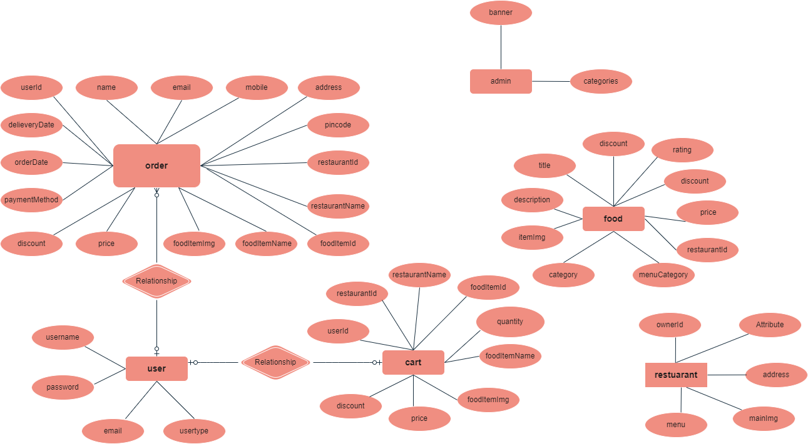

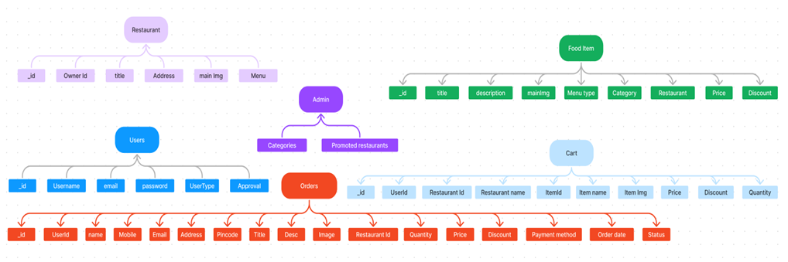

 The SB Foods ER-diagram represents the entities and relationships involved in an food ordering e-commerce system. It illustrates how users, restaurants, products, carts, and orders are interconnected.  Here is a breakdown of the entities and their relationships:

**User:** Represents the individuals or entities who are registered in the platform.

**Restaurant**: This represents the collection of details of each restaurant in the platform. **Admin:** Represents a collection with important details such as promoted restaurants and Categories.

**Products:** Represents a collection of all the food items available in the platform.

**Cart:** This collection stores all the products that are added to the cart by users. Here, the elements in the cart are  differentiated by the user Id.

**Orders:** This collection stores all the orders that are made by the users in the platform.

**FEATURES:**

1. **Comprehensive Product Catalog:** SB Foods boasts an extensive catalog of food items from  various restaurants, offering a diverse range of items and options for shoppers. You can  effortlessly explore and discover various products, complete with detailed descriptions,  customer reviews, pricing, and available discounts, to find the perfect food for your hunger.

2. **Order Details Page**: Upon clicking the "Shop Now" button, you will be directed to an order  details page. Here, you can provide relevant information such as your shipping address,  preferred payment method, and any specific product requirements.

3. **Secure and Efficient Checkout Process:** SB Foods guarantees a secure and efficient checkout  process. Your personal information will be handled with the utmost security, and we strive to  make the purchasing process as swift and trouble-free as possible.

4. **Order Confirmation and Details:** After successfully placing an order, you will receive a  confirmation notification. Subsequently, you will be directed to an order details page, where  you can review all pertinent information about your order, including shipping details, payment  method, and any specific product requests you specified.

In addition to these user-centric features, SB Foods provides a robust restaurant dashboard,  offering restaurants an array of functionalities to efficiently manage their products and sales.  With the restaurant dashboard, restaurants can add and oversee multiple product listings, view  order history, monitor customer activity, and access order details for all purchases.

SB Foods is designed to elevate your online food ordering experience by providing a seamless  and user-friendly way to discover your desired foods. With our efficient checkout process,  comprehensive product catalog, and robust restaurant dashboard, we ensure a convenient and  enjoyable online shopping experience for both shoppers and restaurants alike.

**PREREQUISITES:**

To develop a full-stack food ordering app using React JS, Node.js, and MongoDB, there are  several prerequisites you should consider. Here are the key prerequisites for developing such an application:

**Node.js and npm:** Install Node.js, which includes npm (Node Package Manager), on your development machine. Node.js is required to run JavaScript on the server side. • Download: https://nodejs.org/en/download/

• Installation instructions: https://nodejs.org/en/download/package-manager/

**MongoDB:** Set up a MongoDB database to store hotel and booking information. Install MongoDB locally or use a cloud-based MongoDB service.

• Download: https://www.mongodb.com/try/download/community

• Installation instructions: https://docs.mongodb.com/manual/installation/

**Express.js:** Express.js is a web application framework for Node.js. Install Express.js to handle  server-side routing,middleware, and API development.

• Installation: Open your command prompt or terminal and run the following  command: **npm install express**

**React.js**: React.js is a popular JavaScript library for building user interfaces. It enables developers to  create interactive and reusable UI components, making it easier to build dynamic and responsive web  applications. To install React.js, a JavaScript library for building user interfaces, follow the installation  guide: https://reactjs.org/docs/create-a-new-react-app.html

**HTML, CSS, and JavaScript:** Basic knowledge of HTML for creating the structure of your app, CSS for styling,and JavaScript for client-side interactivity is essential.

**Database Connectivity:** Use a MongoDB driver or an Object-Document Mapping (ODM)  library like Mongoose to connect your Node.js server with the MongoDB database and perform  CRUD (Create, Read, Update, Delete) operations.

**Front-end Framework:** Utilize Angular to build the user-facing part of the application, including product listings, booking forms, and user interfaces for the admin dashboard.

**Version Control**: Use Git for version control, enabling collaboration and tracking  changes throughout the development process. Platforms like GitHub or Bitbucket can host  your repository.

• Git: Download and installation instructions can be found at: https://git scm.com/downloads

**Development Environment:** Choose a code editor or Integrated Development Environment (IDE) that suits your preferences, such as Visual Studio Code, Sublime Text, or WebStorm.

 • Visual Studio Code: Download from https://code.visualstudio.com/download

• Sublime Text: Download from https://www.sublimetext.com/download

• WebStorm: Download from <https://www.jetbrains.com/webstorm/download>

**To Connect the Database with Node JS go through the below provided link:**

Link: https://www.section.io/engineering-education/nodejs- mongoosejs-mongodb/

**To run the existing SB Foods App project downloaded from github:**

Follow below steps:

**Clone the repository:**

• Open your terminal or command prompt.

• Navigate to the directory where you want to store the e-commerce app.

• Execute the following command to clone the repository:

**Git clone: https://github.com/harsha-vardhan-reddy-07/Food-Ordering-App-MERN Install Dependencies:**

• Navigate into the cloned repository directory:

**cd Food-Ordering-App-MERN**

• Install the required dependencies by running the following command:

**npm install**

**Start the Development Server:**

• To start the development server, execute the following command:

**npm run dev or npm run start**

• The e-commerce app will be accessible at http://localhost:3000 by default. You can change the port configuration in the .env file if needed.

**Access the App:**

• Open your web browser and navigate to http://localhost:3000.

• You should see the flight booking app's homepage, indicating that the installation and setup were successful.

You have successfully installed and set up the SB Foods app on your local machine. You can  now proceed with further customization, development, and testing as needed.

**USER & ADMIN FLOW:**

**1. User Flow:**

• Users start by registering for an account.

• After registration, they can log in with their credentials.

• Once logged in, they can check for the available products in the platform. • Users can add the products they wish to their carts and order.

• They can then proceed by entering address and payment details. • After ordering, they can check them in the profile section.

**2. Restaurant Flow:**

• Restaurants start by authenticating with their credentials.

• They need to get approval from the admin to start listing the products. • They can add/edit the food items.

**3. Admin Flow:**

• Admins start by logging in with their credentials.

• Once logged in, they are directed to the Admin Dashboard.

• Admins can access the users list, products, orders, etc.

**PROJECT STRUCTURE**

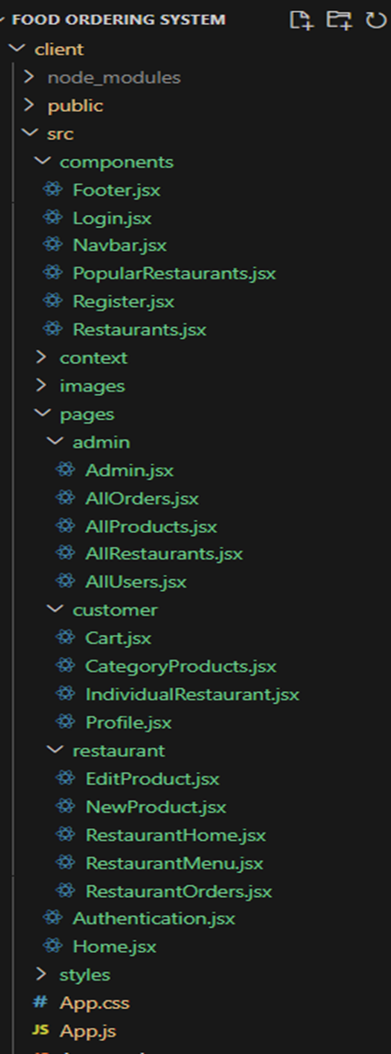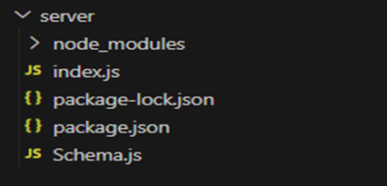

This structure assumes a React app and follows a modular approach. Here's a brief explanation of the main directories and files:

• src/components: Contains components related to the application such as, register, login, home, etc.,

• src/pages has the files for all the pages in the application.

**PROJECT SETUP AND CONFIGURATION:**

**Install required tools and software:**

• Node.js.

Reference Article: <https://www.geeksforgeeks.org/installation-of-node-js-on-windows/>

• Git.

Reference Article: <https://git-scm.com/book/en/v2/Getting-Started-Installing-Git>

**Create project folders and files:**

• Client folders.

• Server folders

Referral Video Link: <https://drive.google.com/file/d/1uSMbPIAR6rfAEMcb_nLZAZd5QIjTpnYQ/view?usp=sharing>

Referral Image:

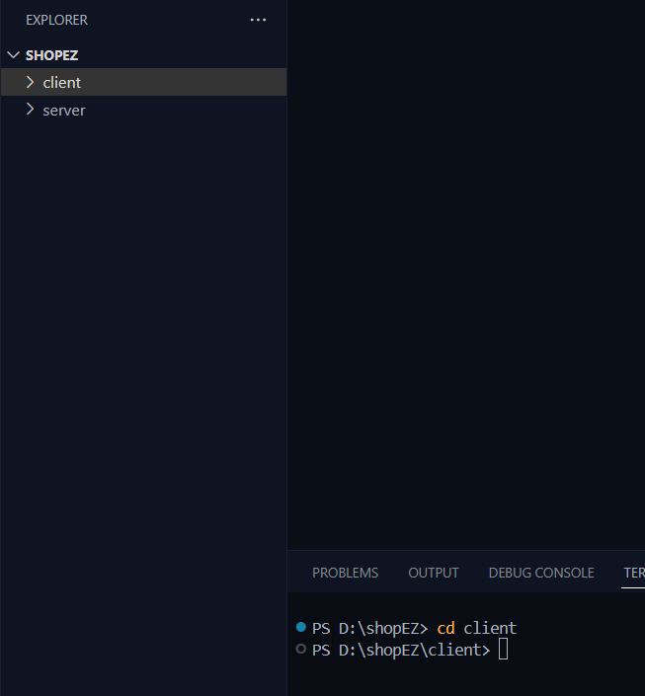

**DATABASE DEVELOPMENT:**

**Create database in cloud video link:-** <https://drive.google.com/file/d/1CQil5KzGnPvkVOPWTLP0h-Bu2bXhq7A3/view>

• Install Mongoose.

• Create database connection.

Reference Video of connect node with mongoDB database: <https://drive.google.com/file/d/1cTS3_-EOAAvDctkibG5zVikrTdmoY2Ag/view?usp=sharing>

Reference Article: <https://www.mongodb.com/docs/atlas/tutorial/connect-to-your-cluster/>

Reference Image:

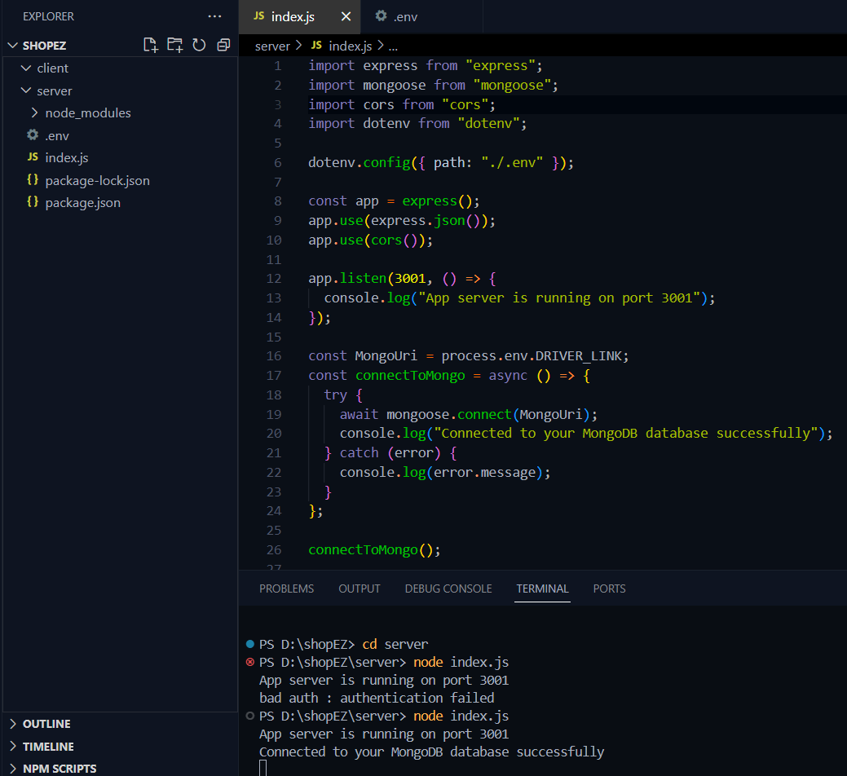

**Schema use-case:**

**1. User Schema:**

• Schema: userSchema

• Model: ‘User’

• The User schema represents the user data and includes fields such as username, email, and password.

**2. Product Schema:**

• Schema: productSchema

• Model: ‘Product’

• The Product schema represents the data of all the products in the platform.

• It is used to store information about the product details, which will later be useful for  ordering.

**3. Orders Schema:**

• Schema: ordersSchema

• Model: ‘Orders’

• The Orders schema represents the orders data and includes fields such as userId,  product Id, product name, quantity, size, order date, etc.,

**4. Cart Schema:**

• Schema: cartSchema

• Model: ‘Cart’

• The Cart schema represents the cart data and includes fields such as userId, product  Id, product name, quantity, size, order date, etc.,

• The user Id field is a reference to the user who has the product in cart.

**5. Admin Schema:**

• Schema: adminSchema

• Model: ‘Admin’

• The admin schema has essential data such as categories, promoted restaurants, etc.,

**6. Restaurant Schema:**

• Schema: restaurantSchema

• Model: ‘Restaurant’

• The restaurant schema has the info about the restaurant and it’s menu

**Schemas:** Now let us define the required schemas